Enhanced Iris Flower Classification Using Optimized Machine Learning Techniques
Namrata G Kademani
Department of Computer Science, Chanakya University
Bangalore, Karnataka, India
Abstract—The classification of Iris flower species is a well-known problem in machine learning and is commonly used to evaluate the performance of classification algorithms. Although many previous studies have reported very high accuracy, they often lack proper validation techniques, which may result in overfitting and unreliable conclusions. In this study, techniques such as feature scaling, hyperparameter tuning, and K-Fold cross-validation are applied to enhance model performance. Only two models—Support Vector Machine (SVM) and Random Forest—are used to maintain simplicity and clarity. Experimental results show that the proposed approach achieves 100% accuracy on the test dataset, while cross-validation accuracy reaches up to 96.66%, indicating strong generalization capability. This demonstrates that even simple models can achieve high performance when proper evaluation techniques are applied.
Keywords—machine learning; Iris dataset; SVM; Random Forest; cross-validation; feature scaling; hyperparameter tuning
I. Introduction
Machine learning is a rapidly growing field that enables systems to learn from historical data and improve their performance without explicit programming. By analysing existing datasets, machine learning algorithms can identify patterns and make accurate predictions. These algorithms can handle both continuous and discrete data and are widely applied in areas such as computer vision, pattern recognition, disease diagnosis, spam detection, weather forecasting, biometric systems, and sentiment analysis.

One of the most commonly used benchmark datasets in machine learning is the Iris flower dataset. This dataset consists of 150 samples belonging to three species: Iris setosa, Iris versicolor, and Iris virginica. Each sample is described using four features: sepal length, sepal width, petal length, and petal width. Using these features, a predictive model can be trained to classify the species of a flower when new data is provided.

The process of building such a model involves several steps. Initially, the dataset is divided into training and testing sets. The training set is used to train the model, while the testing set is used to evaluate its performance. Various machine learning algorithms can be applied for classification, including Naïve Bayes, Logistic Regression, K-Nearest Neighbors (KNN), Decision Trees, Support Vector Machines (SVM), and Random Forest.

The primary objective of this study is to develop an accurate and reliable classification model for Iris flower species. Unlike previous works that rely on multiple algorithms, this study focuses on a simplified approach using optimized models along with proper validation techniques. By evaluating model performance using cross-validation and tuning methods, this research aims to achieve both high accuracy and better generalization.
II. Literature Review
The Iris dataset was presented by Ronald A. Fisher and is available via the University of California, Irvine Machine Learning Repository. This dataset is widely recognized in the field of pattern recognition; Fisher first published it in 1936 [1]. Using this dataset, many machine learning approaches have been used to reliably categorize floral species: k-Nearest Neighbors, Support Vector Machine, Logistic Regression, and Neural Networks. Three primary steps are usually involved in implementing these techniques: segmentation, feature extraction, and classification [2]. In paper [3], the authors highlighted the feature extraction and evaluation of flower species, demonstrating that the k-Nearest Neighbors and Random Forest algorithms achieved the highest accuracy. The method proposed in [4] aims to adjust a pre-trained convolutional neural network (CNN) to improve its ability to detect flower features. Tests on four different datasets showed that the proposed CNN-based model could accurately recognize flowers. Research in [5] also explored the use of machine learning algorithms such as k-Nearest Neighbors, Logistic Regression, Decision Trees, Gaussian Naive Bayes, and Random Forest classifiers for Iris species identification. In paper [6], a CNN-based method for flower classification was proposed, utilizing the VGG19 architecture for feature extraction and SoftMax as the activation function in a transfer learning approach, achieving a training accuracy of 100% and a validation accuracy of 91.1%. Comparative studies using the Iris dataset showed that the Support Vector Machine (SVM) classifier achieved the highest accuracy at 95%, followed by Decision Trees at 93%, and K-Nearest Neighbors at 92% [7]. The authors in [8] applied the Gaussian Naive Bayes supervised learning algorithm to classify Iris species, achieving an accuracy of approximately 95%. A flower recognition system using image processing techniques was developed in [9] to classify flowers based on edge and color features. This system, tested on ten different flower species, achieved over 80% accuracy using the k-Nearest Neighbor algorithm.
III. Methodology
This study follows a structured approach to develop an accurate and reliable machine learning model for Iris flower classification. The methodology includes dataset preparation, preprocessing, model selection, optimization, and performance evaluation.

A. Dataset
The Iris dataset, originally introduced by Fisher, is widely used for classification tasks in machine learning. It consists of 150 samples, with 50 samples for each of the three species: Iris setosa, Iris versicolor, and Iris virginica. Each sample is described using four numerical features: sepal length, sepal width, petal length, and petal width, all measured in centimetres. These features act as input variables, while the species of the flower is the target variable. The dataset is well-balanced and does not contain missing values, making it suitable for classification tasks.
B. Data Preprocessing
Data preprocessing is an essential step to improve model performance. In this study, feature scaling is applied using the StandardScaler technique, which standardizes the data by transforming features to have zero mean and unit variance. This is particularly important for algorithms like Support Vector Machine (SVM), as it ensures that all features contribute equally and prevents bias toward features with larger values. After preprocessing, the dataset is divided into training and testing sets to evaluate the model effectively.
C. Model Selection
To maintain simplicity and efficiency, only two machine learning models are used: Support Vector Machine (SVM) and Random Forest. SVM is effective for classification tasks, especially when data can be separated using kernel functions, while Random Forest improves prediction accuracy by combining multiple decision trees.
D. Hyperparameter Tuning
To further enhance performance, hyperparameter tuning is performed. For the SVM model, different kernel functions are tested to select the best configuration. For the Random Forest model, parameters such as the number of trees and maximum depth are optimized. This helps improve accuracy while reducing the risk of overfitting.
E. Evaluation Metrics
The performance of the models is evaluated using standard metrics such as accuracy, precision, and recall. In addition, cross-validation is applied to obtain a more reliable estimate of model performance by evaluating it on multiple data splits. This ensures that the model is robust and not dependent on a single train-test split.
IV. Results and Discussion
A. Model Performance
The performance of the selected machine learning models is presented in Table I. It can be observed that both Random Forest and Support Vector Machine (SVM) achieved an accuracy of 100% on the test dataset. In addition, the precision and recall values for both models are also equal to 1.00, indicating that all instances were classified correctly without any errors.

TABLE I. Model Performance on Test Dataset
Model | Accuracy | Precision | Recall
Random Forest | 1.00 | 1.00 | 1.00
SVM | 1.00 | 1.00 | 1.00

This result demonstrates that both models are highly effective for the Iris classification task. The perfect scores suggest that the dataset is well-structured and easily separable, allowing the models to perform optimally. However, relying only on test accuracy may not provide a complete understanding of model performance, which highlights the importance of further evaluation using cross-validation.

B. Cross-Validation Results
To ensure the reliability of the models, K-Fold cross-validation was applied, and the results are shown in Table II. The Random Forest model achieved a cross-validation accuracy of 95.33%, while the SVM model achieved a slightly higher accuracy of 96.66%.

TABLE II. Cross-Validation Accuracy
Model | Cross-Validation Accuracy
Random Forest | 95.33%
SVM | 96.66%

These results indicate that both models perform consistently across different data splits, demonstrating good generalization capability. The slightly lower accuracy compared to the test results suggests that the models are not overfitting and provide more realistic performance estimates. Furthermore, the SVM model shows marginally better generalization than Random Forest, making it a more reliable choice for this classification task.

C. Graph Analysis
Figure 1 (Pairplot of Iris Dataset): The pairplot illustrates the pairwise relationships between all features in the dataset. It can be clearly observed that petal length and petal width provide strong separation among the classes, particularly for Iris setosa, which forms a completely distinct cluster. However, a slight overlap is visible between Iris versicolor and Iris virginica, indicating that classification between these two classes is relatively more challenging. This visualization confirms that petal-related features are highly significant for accurate classification.
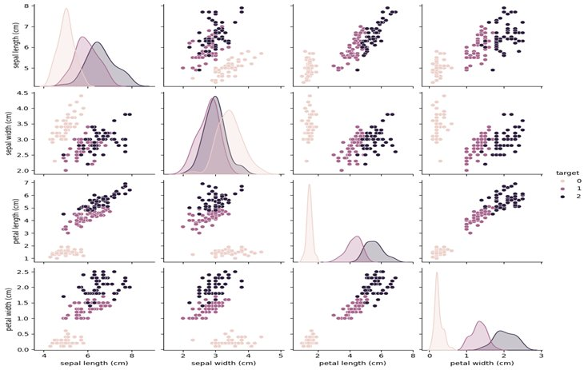
Fig. 1. Pairplot of the Iris Dataset showing pairwise feature relationships across three species.
Figure 2 (Feature Distribution Histograms): The feature distribution graphs show how individual features are spread across the dataset. It is observed that petal length and petal width have distinct distributions for different classes, making them strong discriminative features. In contrast, sepal length and sepal width exhibit overlapping distributions, which reduces their effectiveness in classification. This further supports the importance of petal features in improving model performance.
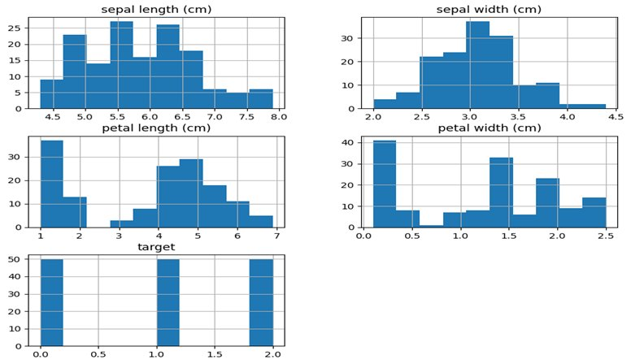
Fig. 2. Feature Distribution Histograms for all four Iris features and the target class.

Figure 3 (Feature Importance — Random Forest): The feature importance graph highlights the contribution of each feature in the classification process. It is evident that petal length and petal width have the highest importance values, indicating that they play a dominant role in predicting the class labels. On the other hand, sepal features contribute less to the model's decision-making process. This result aligns with previous visualizations and confirms that petal features are the key factors in classification.
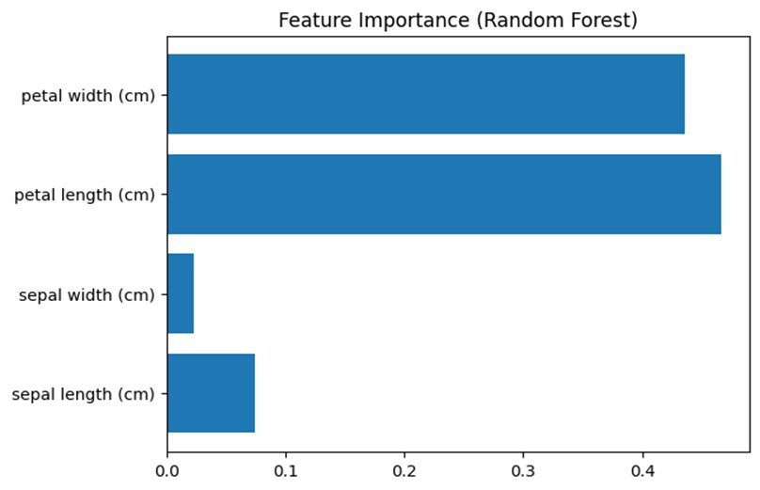
Fig. 3. Feature Importance chart from Random Forest showing petal features as dominant predictors.

Figure 4 (Decision Boundary — PCA Reduced): The decision boundary visualization, obtained after applying PCA for dimensionality reduction, shows how the model separates different classes in a two-dimensional space. The graph reveals three distinct clusters corresponding to the three Iris species, with Setosa clearly separated from the others. A slight overlap is observed between Versicolor and Virginica, indicating that these classes are closer in feature space. Despite this, the model successfully classifies the data with high accuracy, demonstrating its effectiveness.
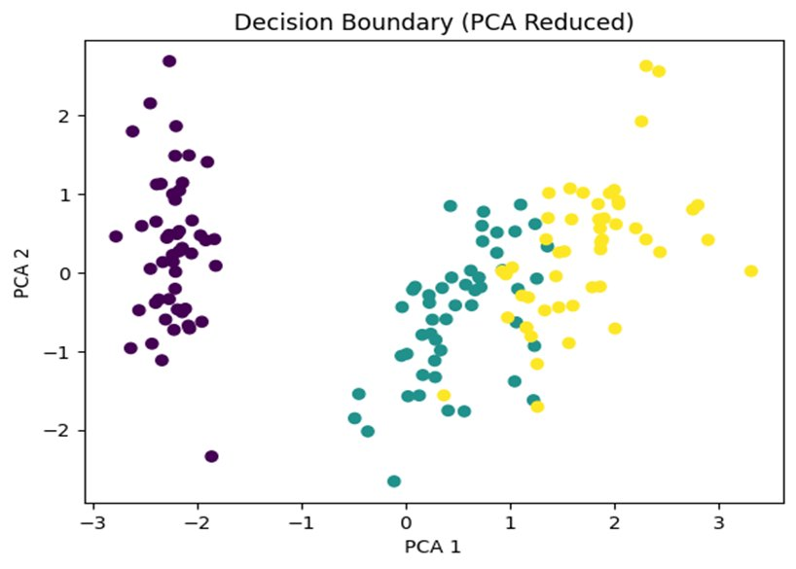
Fig. 4. Decision Boundary plot in PCA-reduced 2D space showing class separation among Iris species.

D. Discussion
The overall results indicate that the models achieved perfect accuracy on the test dataset; however, cross-validation results provide a more realistic evaluation of performance. The following key observations can be made:

1) The test accuracy of 100% indicates that the models perform very well on the given dataset.
2) Cross-validation accuracy (95%–96%) shows that the model performance is consistent across different data splits.
3) The slight decrease in accuracy confirms that the model is not overfitting and provides realistic results.
4) Visualization results (pairplot and feature importance) clearly show that petal features are the most influential, which explains the high classification accuracy.
5) The decision boundary confirms that the dataset is mostly separable, with only minor overlap between classes.
6) Overall, the combination of scaling, tuning, and cross-validation ensures better generalization and reliability of the model.
V. Conclusion
In this study, the classification of Iris flower species was improved using simple yet effective machine learning techniques. By incorporating feature scaling, hyperparameter tuning, and cross-validation, the proposed approach achieves high accuracy while ensuring reliable and consistent performance.

The experimental results demonstrate that both Support Vector Machine (SVM) and Random Forest models are capable of achieving excellent classification accuracy on the Iris dataset. However, the use of cross-validation provides a more realistic evaluation of the model's performance, reducing the risk of overfitting.

Overall, this study highlights that even simple machine learning models can deliver strong results when appropriate preprocessing and evaluation techniques are applied. This approach can be extended to similar classification problems to achieve accurate and reliable outcomes.
References
[1] R. A. Fisher, "The Use of Multiple Measurements in Taxonomic Problems," UCI Machine Learning Repository: Iris Data, 1936. [Online]. Available: http://archive.ics.uci.edu/ml/datasets/Iris
[2] A. Shukla, A. Agarwal, H. Pant, and P. Mishra, "Flower classification using supervised learning," International Journal of Engineering Research, vol. 9, no. 5, pp. 757–762, 2020.
[3] S. Bhutada, K. Tejaswi, and S. Vineela, "Flower recognition using machine learning," International Journal of Researches in Biosciences, Agriculture and Technology, vol. 4, no. 2, pp. 67–73, 2021.
[4] P. A. Dias, A. Tabb, and H. Medeiros, "Apple flower detection using deep convolutional networks," Computers in Industry, vol. 99, pp. 17–28, 2018.
[5] G. Ahuja, M. Aggarwal, J. Tyagi, and O. Mehra, "Identification of different species of iris flower using machine learning algorithms," International Research Journal of Engineering and Technology, vol. 10, no. 1, pp. 434–438, 2022.
[6] S. Desai, C. Gode, and P. Fulzele, "Flower image classification using convolutional neural network," in Proc. 1st Int. Conf. Electrical, Electronics, Information and Communication Technologies (ICEEICT), IEEE, 2022, pp. 1–4.
[7] H. Goel and P. Pushpanjali, "Iris flower classification using machine learning," International Journal of Progressive Research in Engineering Management and Science, vol. 4, no. 5, pp. 655–657, 2024.
[8] Z. Iqbal and M. Yadav, "Multiclass classification with iris dataset using Gaussian Naive Bayes," International Journal of Computer Science and Mobile Computing, vol. 9, pp. 27–35, 2020.
[9] T. Tiay, P. Benyaphaichit, and P. Riyamongkol, "Flower recognition system based on image processing," in Proc. 3rd ICT International Student Project Conference (ICT-ISPC), IEEE, 2014, pp. 99–102.

